Pigg.E.Bank

# Project Overview

The piggy bank. The quintessential tool for children to save their hard-earned money for that special toy, game, or clothing item they’ve been desperately wanting. The “piggy bank” has been around for nearly 600 years where in The Middle Ages, people would save their money in an orange-colored clay pot call a “pygg pot”. These days, having a way for children to save money teaches the importance of financial literacy and almost every child, if not all children have owned a piggy bank of one type or another. Historically, the pig-shaped bank, jar, or box helped save money they got from the Tooth Fairy, money earned from doing chores, or from a weekly allowance. But how do they know how long it’ll take to save up for the special ‘something’? What if they want it now? If they borrow money from their parents, how will they know how long it’ll take to pay them back? Enter into the picture the Pygg.E.Bank app! Pygg.E.Bank is an app that allows children (or even adults) to create a wish list of items they want. Simply enter the item and the cost into the app and it will calculate how long it will take you to save up for the item you desire. Need your item by a specific date? The Pygg.E.Bsnk app can calculate the number of weekly allowances you'll need to save to get that item.

# User Scenario Description

A new user would like to create a list of items they would like to save for and then sort the list in order of least expensive to most expensive. The task should be able to be completed by a child, given that this app is targeted for children to learn savings.

1. After launching the App, the user will be shown a “dashboard”. Because the user has not created a list of items to save for, they will br prompted to start the “wizard” for creating their first wish list. The should click the big right arrow icon.
2. Create a name for this wish list and click the right arrow to proceed. They can click the left arrow to move backwards if needed.
3. Enter in a name for an item and the cost in dollars and cents for US. If internationalized, it will show up in the proper monetary format for the locale. Click the right arrow to proceed. Again, they can click the left arrow to move backwards if needed.
4. The next page prompts the user to continuing to add more items. If they select the +, it will take them to the step 3 again for a new item.
5. When the user decides that there are no more items to add, click the right arrow to proceed.
6. Select if the user wants to track this wish list by entering in an amount of money earned by a set interval, or by getting the items by a set date. Select the radio button for the appropriate choice. If entering in an amount, , enter in the amount as dollars and cents (or what is appropriate for the selected locale and use the drop-down to select [DAY, WEEK, EVERY TWO WEEKS, or MONTHLY]. If selecting a fate, use the calendar control to select a date. When done, click the right arrow to proceed.
7. A success page is displayed. Click the checkbox to exit and return to the dashboard (dashboard not shown in screenshots below).

Note, for internationalized version of this app, the description text will allow the user to enter in the text in their native language and the monetary symbol will be shown in the user’s set locale. This will be determined by the language set by the device.

# Design Considerations for User Interactions

## App Logo

The Piggy Bank logo should be pretty universal but ensure the logo can be replaced by something different for regions that a pig is not appropriate. Also, ensure the logo does not have the US $ on it. There are many piggy bank logos with a coin with a $ on it.

## App Color Scheme

The app should be designed with the ability to skin to provide a different color scheme. Some countries prefer different colored apps and this will help adoption of the app globally.

## Iconography

When designing the app, use icons that are kid friendly, minimize the text needed to be read, and are appropriate for the locale and region the user is in. A few examples are shown below. For example, I originally had start, add, delete, edit, save, and cancel buttons.



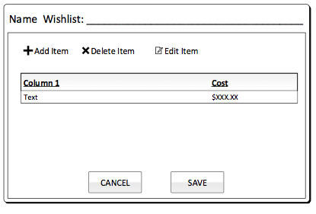

These were subsequently replaced with:

* START: replaced by a large RIGHT ARROW 🡪 icon
* ADD: replaced by a white + in a green circle icon
* DELETE: replaced by a white X in a red circle icon
* EDIT: replaced by a pencil icon
* SAVE: replaced by a green checkbox
* CANCEL: replaced by a red X icon





